ITEC301 DELIVERABLE 3
USER MANUAL

Student Name: | Anthony Shepherd
Student Number: | DQXF8h5N9
Project Title: | Candy Land E-commerce Site
Submission Date: | 2021/07/02

Contents
1. Introduction 3
2. Accessing the website 4
3. Products: Adding, Removing, and updating products 6

Introduction

- Background
Candy Land E-commerce site was created for Mr. Berry in order for him to sell his products during covid 19 and the uncertainties around our lockdowns. Mr. Berry needed a way to keep his family and business a float, he needed a mechanism to still sell his stock no matter the lockdown or restrictions in place.
Being a long-time customer of Mr. Berry and Candy Land and needed to create an ecommerce site there was a unique opportunity to help a business I am particularly fond of stay afloat. I hope to have achieved that with this website.
- About this website
There were multiple different technologies I used in order to create this website,
- Visual Studio Code : Used as my editor I was able to create all the files and manage the directory and code from a single platform. It is easy to use and well supported.
- XAMPP : Was used to run a the site locally, including a local mySQL database.
- HTML and CSS were used: I used bootstrap as well and then when needed I used inline styling in order to override any of the bootstrap I wanted to replace.
- PHP was used for the entire backend.
- There is a single javascript page which connects the html to the php.
- For the database I used mySQL with PhpMyAdmin being the database platform.

Accessing the website

- Customer Registration
When navigating to the candy land website, new users or users that have yet to login have the choice of either registering a new account or logging in.
The Registration process is really simple, with a few personal details for the customer to fill in and then they can begin there shopping.
There is some validation to be aware of but if anything is wrong the system will give you a warning an allow you to correct it.
- Empty Fields – all required fields need to be filled in.
- Email Validation – a valid email address needs to be provided.
- The Password and the Re-Enter Password need to match.
- A valid phone number needs to be entered.
- There is also a check to see if the email address entered is already in the database in which case you already have an account.

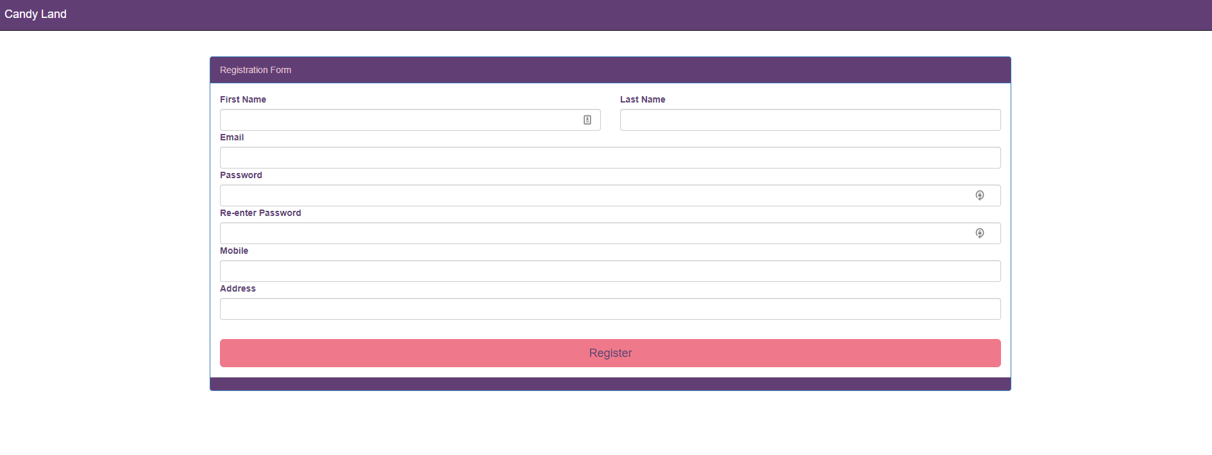
Candy Land Registration Page – to navigate back to the products page click on the Candy Land Logo in the top left.

- Customer Sign In
Customers that already have an account setup can easily sign in from the main page, there is a sign in button in the top right that will display an overlay allowing the user to enter their email and password. If the provided credentials are correct, then the user will be signed in.
If there are any items in their cart from the last time, they were online the items will still be there.
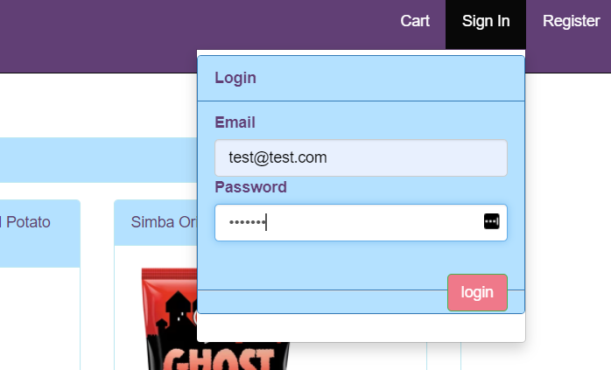

Products: Adding, Removing, and updating products

For all requests, please email me directly with the following information and I will make the updates in the database directly.
Information Required:
- Action: (Adding, Removing, Updating)
  - Adding:
    - Product Name
    - Category
    - Brand
    - Price
    - Description
    - Image
    - Keywords (anything that might help a user find the product they looking for in the search menu)
  - Removing:
    - Product name of the product you wish to remove.
  - Updating:
    - The product name of the product you wish to update.
    - The field you wish to update: Replace Image with this new image.

Cart

Filtering:
- By Brand
- By Category
- Search Keywords
There are a number of different filtering options available to allow the customer to find the product they are looking for, once they find the product, they can click on the ‘add to cart’ button and it will be shown in the cart, once they have added everything they want, simple click the checkout button to place your order.
